Exercise 2:

The Simple Factory Pattern is a creational design pattern which is used to create object. However, the Simple Factory Pattern can only return on object.

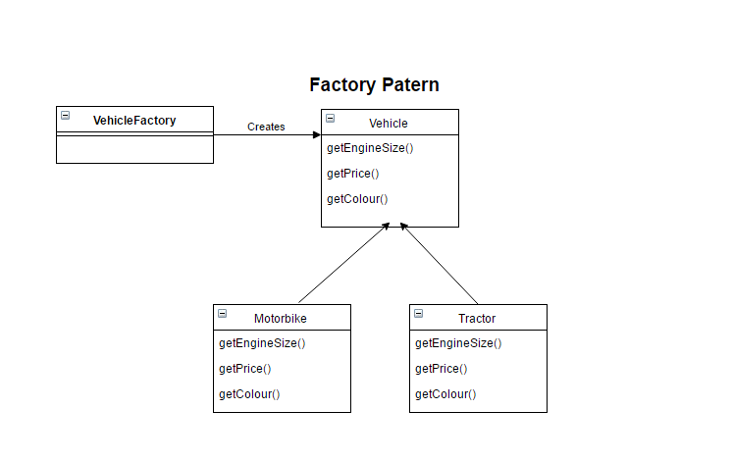

In contrast, the abstract factory pattern is one level above the simple factory. The AFP is able to create multiple factories, which in turn can return multiple object. The class give the responsibility of object creation to other objects rather than using inheritance to handle the subclass instantiation.

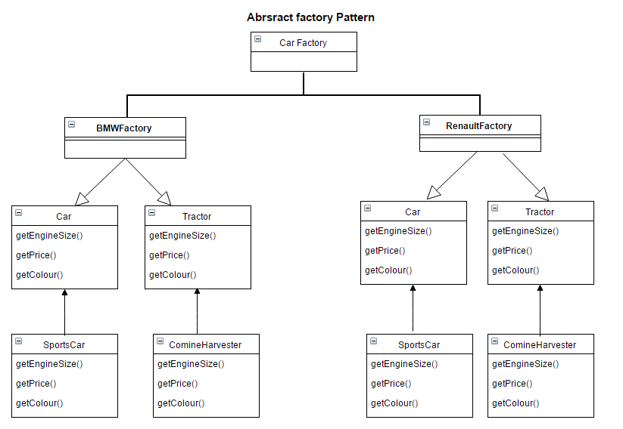

The Factory Method uses one method to make one product related to it’s type. This allows subclasses decide which class it should instantiate.

